Education  - An education contest is conducted each year for Newman students in grades 4 through 12. The categories are art, essay, poetry, computer art, music, and photography.  Three scholarships are awarded to three 8th graders entering Newman High School each year. One scholarship is also awarded to a graduating high school senior entering his/her first year of college.  Youth  - Catholic Daughters have made a commitment to help and encourage the youth of today and support family life issues. We do this through our scholarships and education contests and by being Prayer Partners for Confirmation.  Legislation  The court receives a quarterly report to share at meetings.  Its purpose is to assist members in becoming better informed on public issues, and to support church teachings on human life, human rights, justice and peace. It does not endorse candidates or any political party. |  |  | Our Court Projects Include:  - Pie Sales Fundraisers  - Monthly Coin March  - Charitable Donations  - One Vision Village Festival of Trees  - Blankets for Babies  - Prayers & Support for our Seminarians  - Scholarships  Our State Projects Include:  - Lifesaver Project  - Fall Food Event  - Chaplain Fund  Our National Projects Include:  - Habitat for Humanity  - Holy Cross  - Laboure Society  - Smile Train  - SOAR!  Come join the largest Catholic Women’s organization in America |  |  | Court Joan of Arc #152  Mason City, Iowa  <cda152.weebly.com>  Who We Are…  Affiliated With  Iowa Retired School Personnel Association

Organization’s Purpose  The purpose of the organization is to participate in the religious, charitable and educational Apostolates of the Church.  Mission Statement  Catholic Daughters of the Americas strives to embrace the principles of faith working through love in the promotion of justice, equality and the advancement of human rights and human dignity for all mankind.  Motto  Unity and Charity  Who Can Join  Catholic Daughters is open to all lay and religious women 18 years of age or older who love and support the Church and wish to participate in social and charitable activities. |  |  | Meetings  Our court meets at 6:00 p.m. on the fourth Tuesday of the month, except January and June, in the Holy Family Church hall. Check your church bulletin for changes.  What Do Catholic Daughters Do?  The Catholic Daughter program is based on a CIRCLE OF LOVE. The seven points indicate the needs of the Church and community: Quality of Life, Youth, Education, Spiritual Enhancement, Legislation, Leadership and Family.  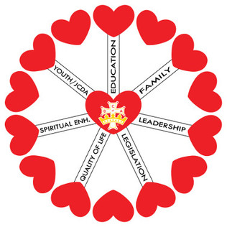 |  |  | Spiritual Benefits  A rosary is prayed before each regular meeting.  A Mass is said each month for our local court. A special Mass is offered in November for all living and deceased members.  When a member or someone in her immediate family passes away, the court will lead and pray a rosary at the visitation.  Prayers are also offered through a prayer chain for times of crisis, illness or death.  Quality of Life  Our court helps those in need by collecting clothing and misc. items for missions and the Baby Pantry.  CDA members collect rosaries that are distributed to hospitals.  Nationally CDA Members participate in WRAP (White Ribbons Against Pornography) and “Make a Difference Day”.  Local courts may choose to support any of ten National Charities supported and endorsed by CDA.

